

**September 16, 2020**

**EXECUTIVE ORDER NO. 1**

In light of the changing restrictions and guidelines of COVID-19 regarding the number of participants that may gather in a room, meeting hall, stadium, etc., for a meeting of any kind varies from Department to Department and even within a single Department, therefore, in the cases of Auxiliary, District, and Department meetings, audits, official visits, etc., **Section 212—**

**Quorum becomes effective immediately: “Five (5) members in good standing shall constitute a quorum for the transaction of business at any meeting of the Auxiliary.”**

In areas where members, due to age, health, etc., are reluctant/refuse to participate in in-person meetings to establish a quorum for the transaction of business, the Auxiliary President may appeal in writing to the Department President for written permission (to be attached to the meeting’s minutes) that the members needed to establish a quorum may attend virtually. Should audits or official visits be completed virtually, the audit/books may be signed at a later date with a copy of the written permission from the Department President attached.

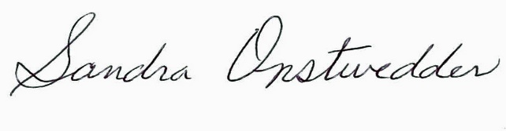 

By order of Sandra Onstwedder, National President

Veterans of Foreign Wars of the United States Auxiliary

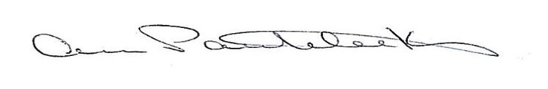

Attest: Ann Panteleakos, National Secretary-Treasurer

Veterans of Foreign Wars of the United States Auxiliary

**EXECUTIVE ORDER NO. 1, issued by National President Sandra Onstwedder, and effective**

**September 16, 2020, supersedes Executive Order No. 2 issued March 26, 2020 by then-National**

**President Peggy Haake.**

